**SAMANTA’S YANTRA’S**

**Abstract**

This project intends to the preservation of the Equipments made by Pathani Samanta (Samaanta Chndrsekhar), for the purpose of naked eye astronomical observations. Precisely we will delv deeper into the mathematics and construction of these yantras, and find out various ways to make them compact and carriable, so that it can be mass produced and every school and student can afford to use it.

**Basic Information about Samanta Chandrasekhara**

Samanta Chandra Sekhar (1835-1904), popularly known as Pathani Samabta in Orissa, worked in astronomy following traditional methods, completely unaware of the telescope and other aids developed in the west. He took observations with ingenious and handy instruments, all fabricated by himself. His study and observations are recorded in an invaluable classic, the Siddhanta Darpana, composed in beautiful metrical Sanskrit verse. It contains many original contributions of Sumanta in observation, calculation, instrumentation, theory and model. Hence it shows appreciable improvements over the earlier classics like Surya Siddhanta and Siddhanta Siromani. The results of Chandra Sekhar’s observations are often comparable with modern data and his predictions in positional astronomy are in fair agreement with actual occurrence of astronomical events, even today. In view of all these, Samanta Chandra Sekhar stands out as a great naked eye astronomer who had reached the limit of accuracy in observation. The aim of this paper is to bring out the merits of Siddhanta Darpana and the genius of its author to the notice of a large scientific community.

**First Basic Information about the Equipmet (Yantra’s):**

**Mānayantra**: It is a T-shaped instrument made of two sticks, one standing vertical to the other. Former one got holes or marks in each unit. The observer can determine the height and distance of a distant object simultaneously by observing the object inside those holes taking two readings from different positions. This is the instrument which made Samanta popular among the On the time measurement units and measuring instruments common people of Odisha since its working principle is very simple based on rudimentary geometry.

**Golayantra**: It is a replica of earth surrounded by the sky. In other words it represents a globe surrounded by the celestial sphere. As we know the globe is used to locate a place on the earth through imaginary latitude and longitude lines on it. Similarly imaginary lines are drawn across celestial sphere to determine position, motion and their respective rising and setting times of heavenly bodies throughout the year.

**Suryaghadi**: It was fabricated by Samanta Chandra Sekhar and its model version was installed by Prof. Jogesh Chandra Roy in Ravenshaw College (now Ravenshaw University). Although it is later replaced by different people it has been showing correct local time even now and attract people of different parts of globe.

**Chapayantra**: It gives informations on time, date and month.

**Golardha Yantra**: It was designed by Samanta by using the lower part of the circular water pot and a stick of length equivalent to the radius of the pot inserted vertically upward at its center. This shows equally accurate time as the other sundials.

**Chakrayantra**: It is also a Sundial fabricated by Samanta following the similar principle of parallel axis to axis of rotation of earth and plane parallel to the equatorial plane. **Swayambahayantra**: It is an instrument consisting of a container filled with water and an indicator plate connecting with a pot floating on the water. Continuous evacuation of water with a constant rate indicates constant time interval in the indicator plate. Samanta was keeping this instrument all the time with him, since it can work in both day and night time independent of sky conditions (whether cloudy or clear, sunny or night).

**Geometry for the creation of these equipments**

**Manayantra**

Samanta made Mánayantra out of a stick 42 digits long, attaching a crosspiece of 4.5 digits to one end. The trigonometrical functions of sines and cosines were all committed in his mind.

Manayantra was one of the euipments that has made Samanta the public figure in Odisha. He could corectly esstimate the heights of distant objects with the Mnyantra. The calculations for every equipment was done manually, and Samanta did all the calculations in his memory.

Let us assume two unequall pieces of wood, AB and OC

A

B

O

C

Now also as in the figure AO is not equal to BO

Here the Vertical Rod OC consists of small holes, facing the

horizontal arms at equal intervals. A rider could be moved on

the vertical groove making one single hole at a disered position.

**Mathematics involved in the creation of these equipments**

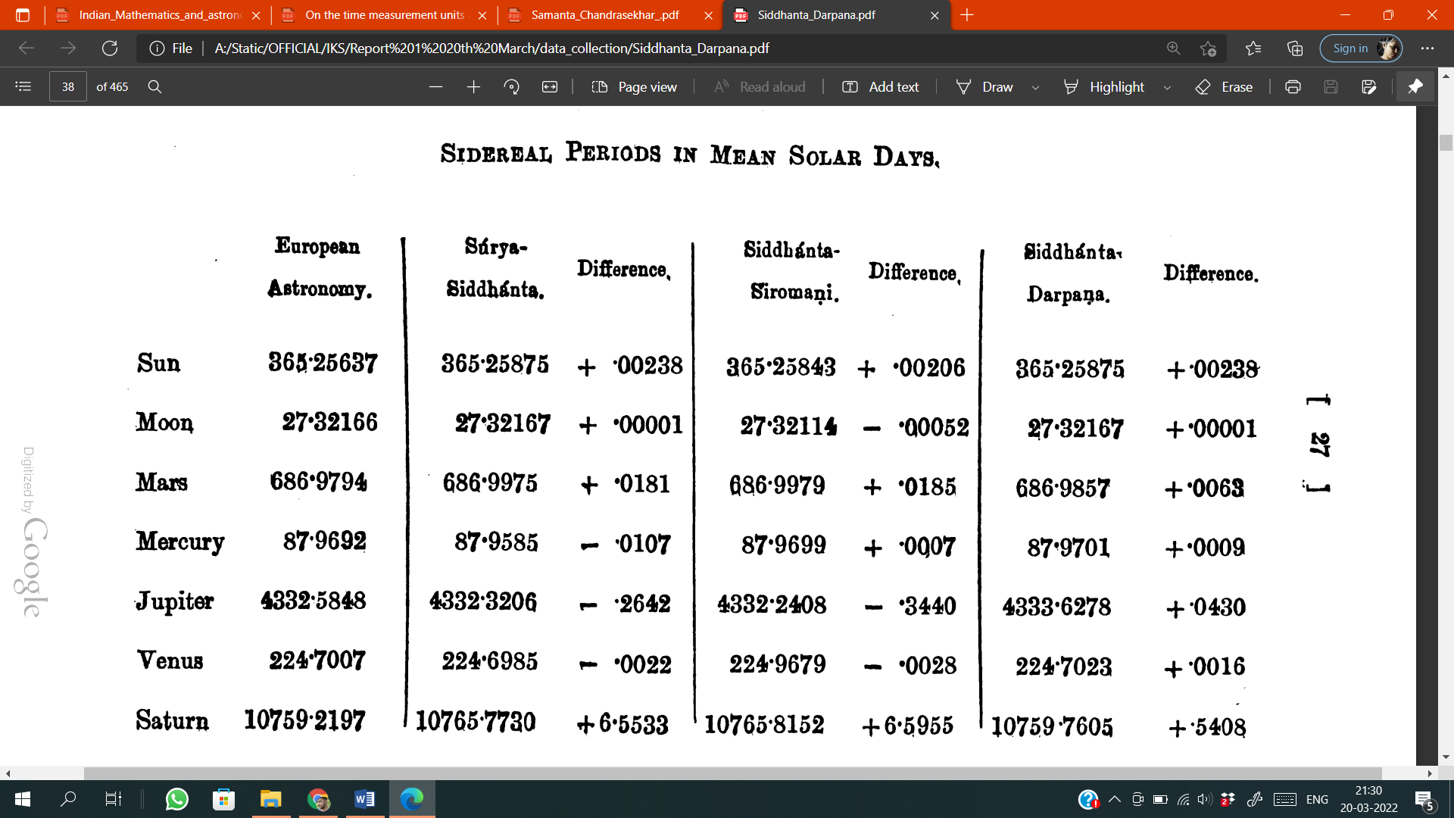

**Ways to make these eqipments handy**

**Targets to be achieved by spreading a master plan for its massive production**

**Tasks need to be done:**

To site the problems of the ancient mathematics

Find about all the equipments and delve deeper in the construction of them

Create innovative solutions to make these equipments compact and pocket sized.

Analyse The **“Siddhanta Darpana”** Properly

**References:**

1. <https://www.ias.ac.in/public/Volumes/reso/005/07/0088-0091.pdf> (Indian Mathematics and Astronomy: Some Landmarks)
2. P C Naik and L Satpathy, Current Science, 69(8), 705 (1995)
3. P C Naik, Current Science, 89(1), 211 (2005)
4. Mahamahopadhyaya Shri. Chandrasekhar Singh Harichandan Mohapatra Samanta , Sidhanta Darpan (Dhramagrantha Store Publication, Cuttack, 1975)